17-4-2020

SUNSHINE COAST FRASER AND BURNETT DISTRICT TOUCH ASS
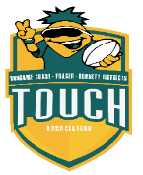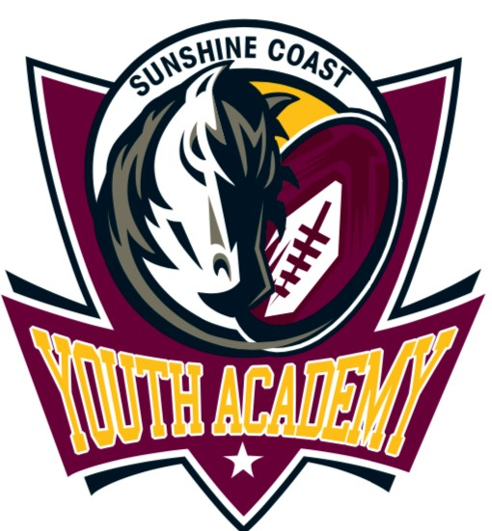

Dear SCFBDTA Squad Player,
SCFBDTA would like to take this opportunity to thank you for your patience through an unknown period due to the Health pandemic Covid 19.
With the Government restrictions in place to ensure everyone’s health and safety Touch football is under suspension. Whilst this suspension is in place, we as a Region are still working towards having events and competitions ready on return.
Junior State Champs is a QTF hosted event and with some changes in 2020 the event will be going ahead 18th -20th September 2020 on the Sunshine Coast in conjunction with NYC subject to the Government recommendations and authorisation. This event will be a ‘in camp’ event and unfortunately due to the unknown details a confirmed price is not available at this time. We can estimate on previous years it will be approximately $600-$650 inclusive of accommodation, buses to and from the fields, meals, physio etc.
2020 will be a year of a new modern SCFBDTA Uniform. Players will be given more details when selected in teams.
Due to the pandemic we are limited to how and when we can finalise these teams, however we assure you we will endeavour to do so as quick as we can when safe.
We ask squad members to continue personal fitness whilst in isolation, this will be the most important part of the game on return.
We understand this pandemic may have caused tough situations within families and understand if circumstances for squad members have changed.
Should you no longer be able to accept your invitation to be a part of the SFCBDTA Squad please email nat@sctouch.com.au.
If there is anything further I can assist with feel free to let me know.
Kind regards
Nattalie DeRossi
SCFBDTA Regional Manager

